# CS 255 System Design Document Template

This template lays out all the different sections that you need to complete for Project Two. Each section has guidance to prompt your thinking. You will need to continually reference the interview transcript as you work to make sure that you are addressing your client’s needs. There is no required length for the final document. Instead the goal is to complete each section based on what your client’s needs are. Remove this note when you are finished, and replace all bracketed text with the relevant information.

## UML Diagrams

### UML Use Case Diagram

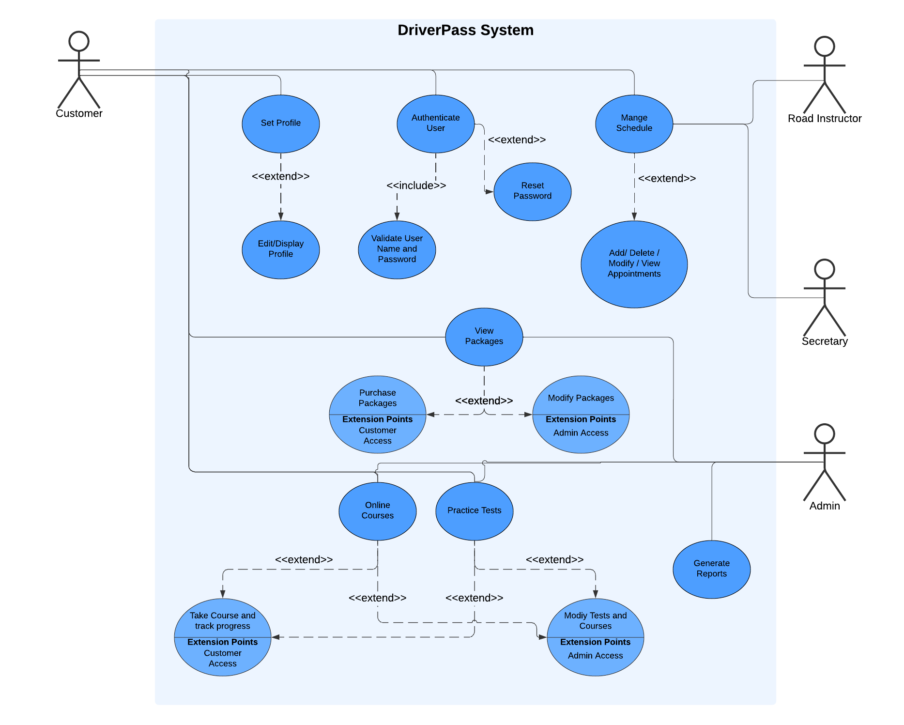

### UML Activity Diagrams

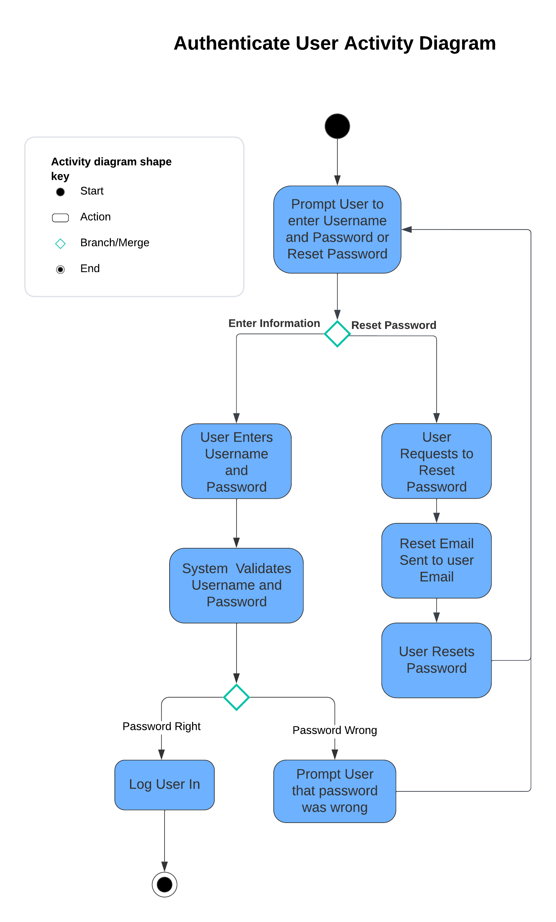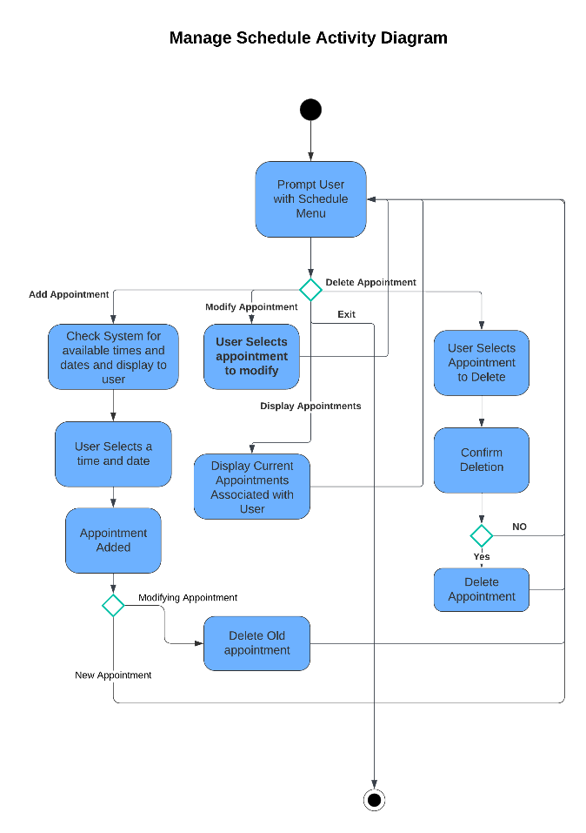

### UML Sequence Diagram

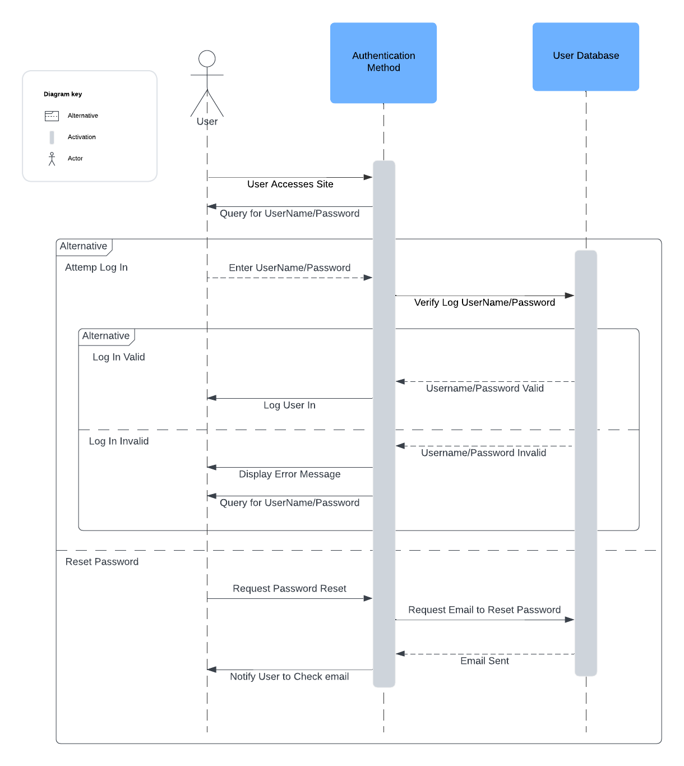

### UML Class Diagram

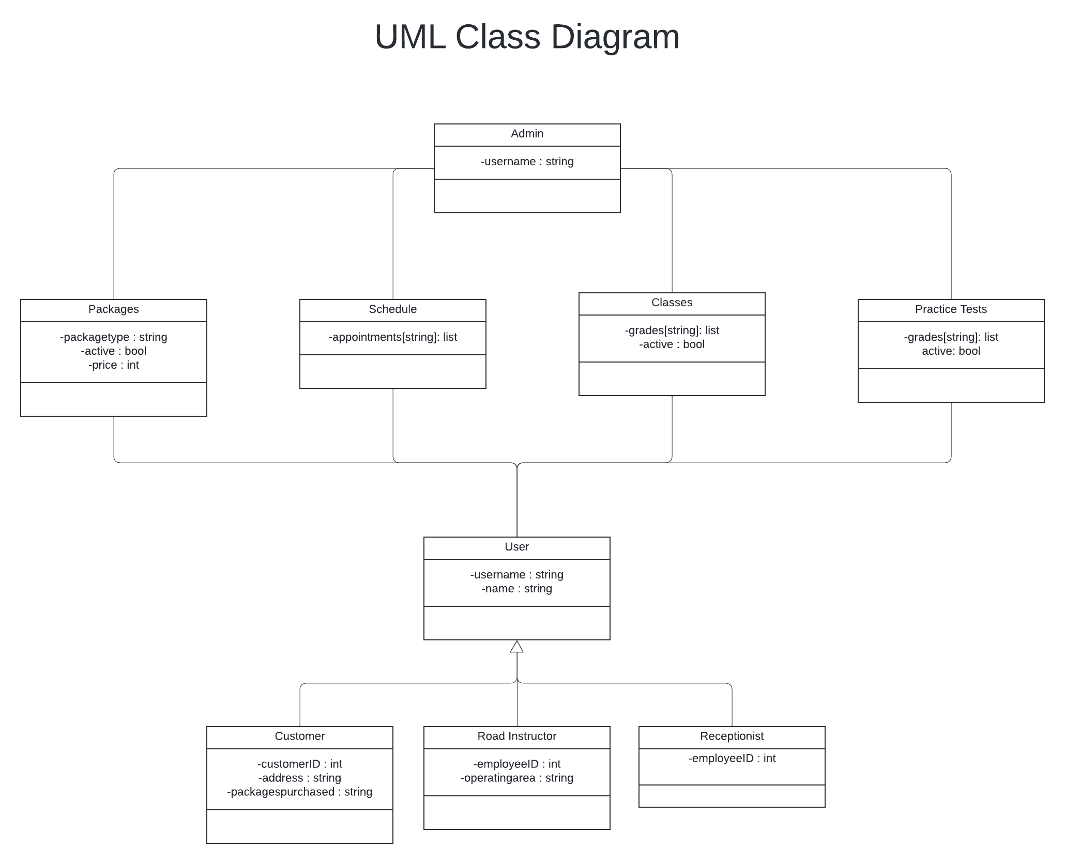

## Technical Requirements

Based on the diagrams on the system I would recommend several technical requirements for the system. The first would be some sort of place to host the system. DriverPass will have to decide if they want the cost and responsibility of running their own server, or whether they would like to have it be cloud based, which while there is less up front cost, the price is usually effected by traffic. Given they are new, a cloud-based service might be beneficial as it could easily scale with the growth of the client base. DriverPass can always begin hosting their own server later. Other hardware could include simple workstations for receptionists and admin, while Road Instructors would probably be required to work remotely via the site on their own computer. Access to the site would be provided via the website for customer use, with a separate interface for road instructor and receptionist users to control scheduling. Admin accounts will need to have access to all parts of the system and have a tool for printing reports, modifying packages, blocking users, and updating practice tests and online classes. Depending on how DriverPass wants the system to operate, classes and practice tests will need to have an interface built for them as well, like an interactive test online. On the front end for the user, it needs to be able to organize and display lessons and tests, then save progress for a user. While on the back end it needs to be able to generate reports, be modified and save all attempts into gradebooks. Once all parts are in place, operation can change focus on keeping the tests and lessons up to date, and marketing.